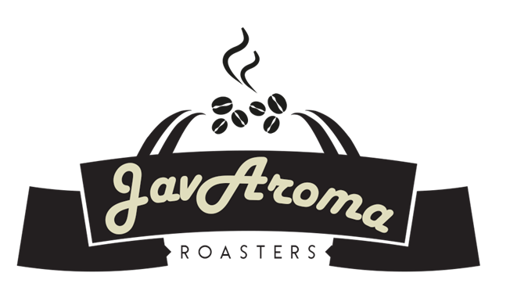

**WHOLESALE TERMS AND CONDITIONS AGREEMENT**

CONFIDENTIAL APPLICATION FOR CREDIT

Terms and Conditions

Applicant certifies that the information submitted on the Wholesale Application and all information in this document is true and correct. The applicant authorizes JavAroma Roasters LLC to charge the new wholesale account in the form of a credit card, cash or direct deposit for the first order to establish the business relationship.

JavAroma Roasters LLC will not disclose credit information about the applicant to any other persons without applicant's prior written approval. If credit is extended, I(we) further agree that such extension of credit shall be subject to the following:

1) I(we) shall pay the amount or amounts, as evidenced by the account, not later than thirty days following the day in which the indebtedness was incurred.

2) I(we) agree to be bound by the Terms and Conditions of as they may be amended from time to time. At each change, JavAroma Roasters LLC will make the applicant aware of such changes in advance.

3) In the event that a delinquent account is placed in the hands of a licensed collector or an attorney for collection, or suit is instituted on this account, I(we) agree to pay, in addition to the amount of the delinquent account and interest, all costs of such collection, including without limitation all collector's or attorney's fees and court costs.

4) I(we) certify that we are not currently insolvent or bankrupt, nor are we contemplating bankruptcy. In the event that bankruptcy is contemplated, I(we) agree to inform JavAroma Roasters LLC immediately.

TERMS AND CONDITIONS OF SALE

1. *Payment Terms.* Net amount of invoice shall be paid in full within 30 days of date of invoice. JavAroma Roasters LLC (“Seller”) reserves the right to modify or terminate credit limits, restrict the terms of payment, and/or to require payment prior to time of shipment of the product, if, in Seller's opinion, Customer’s (“Buyer's”) financial condition or other circumstances so warrant. Buyer agrees to pay interest at the rate of 18% APR or the maximum permitted by law on any and all delinquent balances, and to pay any and all attorneys' fees and other costs incurred by Seller in collecting delinquent account balances.

2. *Orders*. Seller must have a 48 hour notice of a needed order. An order placed with and accepted by Seller may be canceled only if the order has not been filled and with Seller's consent. All orders are subject to acceptance by Seller's sales office at Mitchell, IN and subject to Seller's production and government certification schedules. In cases of short supply of product, reasonable allocations may be necessary.

3. *Product Exclusivity*: Buyer will agree to purchase exclusively from JavAroma Roasters LLC for all coffee-related products within the business of __________________________. Failure of this, will result in the potential termination of the agreement.

4. *Claims.* Claims for defective product, shortages, delays, or failures in shipment or delivery, or for any other cause, shall be deemed waived and released by Buyer, unless written notice is provided to Seller within two calendar days after arrival of the product. In no case is product to be returned by Buyer without first obtaining Seller's permission. Seller may, after giving reasonable notice to Buyer and during normal business hours, inspect any product in Buyer's possession that is the subject of any complaint or claim by Buyer, and may conduct or perform such tests and examinations as Seller shall deem necessary to verify the weight and quality of the product. Under no circumstances shall Seller be liable for any indirect, special, incidental, or consequential damages, or for any other losses, damages or expenses, directly or indirectly, in connection with or by reason of the use of or inability to use the product. Seller does not make any warranties with respect to the use, sale or other transfer of the coffee bags/beans by the other party or by any third party. In no event will JavAroma Roasters LLC be liable for direct, indirect, special, incidental, or consequential damages, that are in any way related to the coffee product.

4. *Force Majeure*. Seller shall not be liable for any delay in the performance of orders, or in the delivery or shipment of product, or for any damages suffered by Buyer by reason of such delay, if such delay is, directly or indirectly, caused by, or in any manner arises from, labor difficulties, transportation delays, shortage of labor, fuel, power, materials or supplies, accidents, acts of God, or any other cause or causes (whether similar or dissimilar to the foregoing) beyond the reasonable control of Seller.

5. *Taxes*. Buyer shall be responsible for all sales, use, general excise, excise or other taxes applicable to this order.

6. *Governing Law.* This order and the terms and conditions contained herein shall be governed by and construed in accordance with the laws of the State of Indiana.

7. *Arbitration.* Any claim, dispute or controversy arising out of or relating to this order or the performance or breach thereof shall be submitted to binding arbitration in the City and County of Mitchell, IN in accordance with the rules and procedures of the American Arbitration Association then in effect.

8. *Modification*. These terms and conditions shall be the exclusive and final expression of agreement of Buyer and Seller with respect to the order, and no waiver, alteration or modification of any of the terms and conditions shall be valid unless made in writing and signed by an appropriate officer of Seller. Seller hereby gives notice that it objects to the inclusion of any different or additional terms unless specifically agreed upon by Seller in writing. The inclusion of any such different or additional terms shall not constitute

9*. Transfer of Rights*: This Agreement shall be binding on any successors of the parties. Neither party shall have the right to assign its interest in this Agreement to any other party, unless the prior written consent of the other party is obtained.

